**PARKING LOT**

**(Python Project) -CORE CSE**

**Name – Swapnil Bankar**

**Batch – H-J- Bhabha**

**Table of contents –**

1. **Introduction**
2. **Python Files**
3. **Key Features**
4. **Language used**

**Introduction:**

**The objective of these parking lot system In which when car will enter they need to park the car , first it will check the nearest place to parked the car at any point of time , that is we can give them slot 1 and after that increases the no of slots according to car which we have parked . If space is not left car should be wait .**

**Python Files:**

**Parking.py : hear I am using Heapq and some collection library like defaultdict and OrderderDict. Hear I have create a one class for car and print with string concanited with car registration no and car color. Create another class parkingLot , and create one function for managing a total slots and using ordered dictionary ( we need to maintain a order of car while showing the status of slots). For more detail go with the code .**

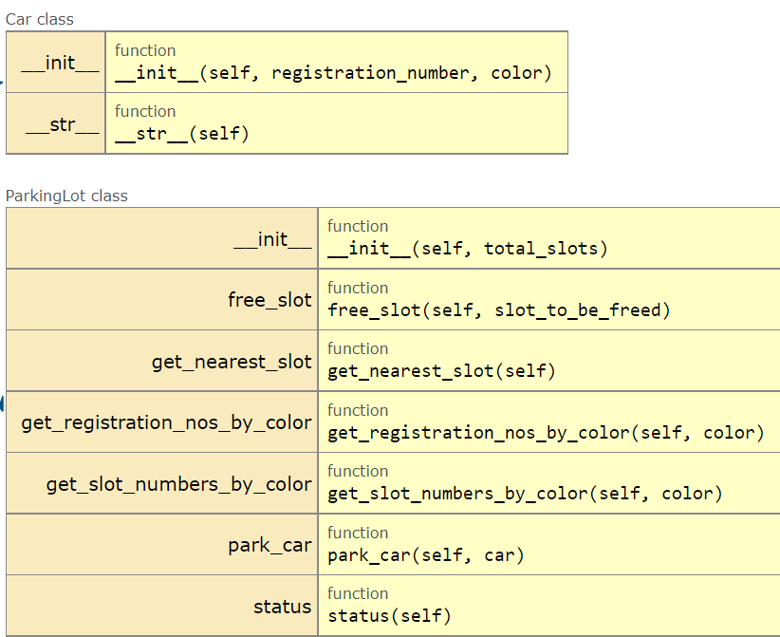

**Key Features:**

Due to government regulations, the system is having –

a). Registration number of all cars of a particular colour

b). Slot numbers at which car is parked with registration number

c). Slot numbers of all slots where car of a particular colour is parked.

**Language used :**

**Python 3.7 In Visual Studio .**